**VIVEKANAND EDUCATION SOCIETY’S INSTITUTE OF TECHNOLOGY**

**Department of Computer Engineering**



Project Report on

IoT Based Prepaid Electric Meter

In partial fulfillment of the Fourth Year, Bachelor of Engineering (B.E.) Degree in Computer Engineering at the University of Mumbai Academic Year 2017-2018.

**Submitted by**

Mukul Ramchandani (D17 - A , Roll no - 63)

Aishwarya Aryamane (D17 - C , Roll no - 04)

Siddharth Bellani (D17 - C, Roll no - 06)

Shraddha Bhinge (D17 - C, Roll no - 10)

**Project Mentor**

Mrs. Indu Dokare

(2017-18)

**VIVEKANAND EDUCATION SOCIETY’S INSTITUTE OF TECHNOLOGY**

**Department of Computer Engineering**



**Certificate**

This is to certify that ***Mukul Ramchandani, Aishwarya Aryamane, Siddharth Bellani, Shraddha Bhinge*** of Fourth Year Computer Engineering studying under the University of Mumbai have satisfactorily completed the project on “***IoT based Prepaid Electric Meter***” as a part of their coursework of PROJECT-II for Semester-VIII under the guidance of their mentor ***Prof. Mrs. Indu Dokare*** in the year 2017-2018.

This thesis/dissertation/project report entitled ***IoT based Prepaid Electric Meter*** by ***Mukul Ramchandani, Aishwarya Aryamane, Siddharth Bellani, Shraddha Bhinge*** is approved for the degree of B.E. Computer Engineering.

|  |  |
| --- | --- |
| Programme Outcomes | Grade |
| PO1,PO2,PO3,PO4,PO5,PO6,PO7,  PO8, PO9, PO10, PO11, PO12  PSO1, PSO2 |  |

Date:

Project Guide: Mrs. Indu Dokare

**Project Report Approval**

**For**

**B. E (Computer Engineering)**

This thesis/dissertation/project report entitled ***IoT based Prepaid Electric Meter*** by ***Mukul Ramchandani, Aishwarya Aryamane, Siddharth Bellani, Shraddha Bhinge*** is approved for the degree of ***B.E. Computer Engineering***.

Internal Examiner

---------------------------------------------

External Examiner

---------------------------------------------

Head of the Department

-----------------------------------------------

Principal

-----------------------------------------------

Date:

Place: Mumbai, Chembur

**Declaration**

We declare that this written submission represents our ideas in our own words and where others' ideas or words have been included, we have adequately cited and referenced the original sources. We also declare that we have adhered to all principles of academic honesty and integrity and have not misrepresented or fabricated or falsified any idea/data/fact/source in our submission. We understand that any violation of the above will be cause for disciplinary action by the Institute and can also evoke penal action from the sources which have thus not been properly cited or from whom proper permission has not been taken when needed.

|  |  |
| --- | --- |
| -----------------------------------------  Aishwarya Aryamane, D17C-04 | -----------------------------------------  Siddharth Bellani, D17C-06 |
| -----------------------------------------  Shraddha Bhinge, D17C-10 | -----------------------------------------  Mukul Ramchandani, D17C-63 |

Date:

**ACKNOWLEDGEMENT**

We are thankful to our college Vivekanand Education Society’s Institute of Technology for considering our project and extending help at all stages needed during our work of collecting information regarding the project.

It gives us immense pleasure to express our deep and sincere gratitude to Assistant Professor **Mrs. Indu Dokare** for her kind help and valuable advice during the development of project synopsis and for her guidance and suggestions.

We are deeply indebted to Head of the Computer Department **Dr.(Mrs.) Nupur Giri** and our Principal **Dr. (Mrs.) J.M. Nair,** for giving us this valuable opportunity to do this project.

We express our hearty thanks to them for their assistance without which it would have been difficult in finishing this project synopsis and project review successfully.

We convey our deep sense of gratitude to all teaching and non-teaching staff for their constant encouragement, support and selfless help throughout the project work. It is great pleasure to acknowledge the help and suggestion, which we received from the Department of Computer Engineering.

We wish to express our profound thanks to all those who helped us in gathering information about the project. Our families too have provided moral support and encouragement at several times.

**Computer Engineering Department**

**COURSE OUTCOMES FOR B.E PROJECT**

Learners will be to: -

|  |  |
| --- | --- |
| **Course Outcome** | **Description of the Course Outcome** |
| CO 1 | Able to apply the relevant engineering concepts, knowledge and skills towards the project. |
| CO2 | Able to identify, formulate and interpret the various relevant research papers and to determine the problem. |
| CO 3 | Able to apply the engineering concepts towards designing solution for the problem. |
| CO 4 | Able to interpret the data and datasets to be utilized. |
| CO 5 | Able to create, select and apply appropriate technologies, techniques, resources and tools for the project. |
| CO 6 | Able to apply ethical, professional policies and principles towards societal, environmental, safety and cultural benefit. |
| CO 7 | Able to function effectively as an individual, and as a member of a team, allocating roles with clear lines of responsibility and accountability. |
| CO 8 | Able to write effective reports, design documents and make effective presentations. |
| CO 9 | Able to apply engineering and management principles to the project as a team member. |
| CO 10 | Able to apply the project domain knowledge to sharpen one’s competency. |
| CO 11 | Able to develop professional, presentational, balanced and structured approach towards project development. |
| CO 12 | Able to adopt skills, languages, environment and platforms for creating innovative solutions for the project. |

**Abstract**

The non-linearity in the graph of availability versus requirement for electricity have been eventually increased in the past few years in India. People aren’t aware the way or amount of electricity (real-time) they are using it on daily/monthly basis. The consumption of electricity and the above scenario can be controlled by introducing the prepaid billing facility in the electric meter.

     Our objective is to create an IoT based prepaid electric meter which will give real-time stats of the electricity consumption of a particular electric meter and user can see the stats anywhere and at any time on the web interface that will be developed by us. The web interface will also be useful for re-charging the electric meter and will also have zero-hour policy feature for emergency cases. With this change in today’s electric meter and its billing facility, we believe that the electricity can be consumed efficiently and people will be much aware about their usage and help them to take actions to save electricity.

**TABLE OF CONTENTS**

**CHAPTER INDEX**

|  |  |  |
| --- | --- | --- |
| **Chapter No.** | **Title** | **Page No.** |
|  | **Title Page** | 1 |
| **Certificate Page** | 2 |
| **Report Approval** | 3 |
| **Declaration** | 4 |
| **Acknowledgement** | 5 |
| **Course Outcomes** | 6 |
| **Abstract** | 7 |
| **1** | **Introduction** | 11 |
| 1.1 | Introduction to the project | 11 |
| 1.2 | Motivation for the project | 11 |
| 1.3 | Drawback of the existing system | 12 |
| 1.4 | Problem Definition | 12 |
| 1.5 | Relevance of the Project | 12 |
| 1.6 | Methodology used | 13 |
| **2.** | **Literature Survey** | 14 |
| 2.1 | Literature survey and its various sources | 14 |
| **3.** | **Requirement Gathering** | 16 |
| 3.1 | Functional Requirements | 16 |
| 3.2 | Non-Functional Requirements | 17 |
| 3.3 | Constraints | 17 |
| 3.4 | Hardware, Software, Techniques and Tools - Requirements | 17 |
| 3.5 | Selection of the Hardware, Software, Techniques and Tools | 18 |
| **4.** | **Proposed Design** | 19 |
| 4.1 | Block diagram representation of the proposed system | 19 |
| 4.2 | Modular design of the system | 21 |
| 4.3 | Detailed Design | 22 |
| 4.3.1 | Data Flow Diagram | 22 |
| 4.3.2 | Flowchart | 27 |
| 4.4 | Project scheduling and tracking using Gantt chart | 29 |
| **5.** | **Implementation Details** | 30 |
| 5.1 | Algorithms for the respective modules developed | 30 |
| 5.2 | Comparative Analysis with the existing algorithms | 35 |
| 5.3 | Evaluation of the developed system | 35 |
| **6.** | **Testing** | 36 |
| **7.** | **Result Analysis** | 38 |
| 7.1 | Simulation Model | 38 |
| 7.2 | Screenshots of UI | 39 |
| 7.3 | Reports Generated | 41 |
| **8.** | **Conclusion** | 42 |
| 8.1 | Limitations | 42 |
| 8.2 | Conclusion | 42 |
| 8.3 | Future Scope | 42 |
|  | **References** | 43 |
|  | **Project Review** | 44 |
|  | **Appendix** | 46 |
|  | Paper 1 | 46 |

**List of Figures**

|  |  |
| --- | --- |
| Figure 1 | Block Diagram |
| Figure 2 | Modular Diagram |
| Figure 3.1 | DFD Level 0 |
| Figure 3.2 | DFD Level 1 |
| Figure 3.3 | DFD Level 2 |
| Figure 4 | Flowchart |
| Figure 5 | Gantt Chart |
| Figure 6 | Simulation Model |
| Figure 7 | Sign In |
| Figure 8 | Real time consumption page |
| Figure 9 | Statistical graph |
| Figure 10 | Recharge portal |
| Figure 11 | Recharge successful |
| Figure 12 | Consumption reports generated monthly and yearly |

**List of Tables**

|  |  |
| --- | --- |
| Table 1 | Comparison between existing system and prepaid electric meter |
| Table 2 | Evaluation of the proposed system |
| Table 3 | Unit testing cases |

**CHAPTER 1: INTRODUCTION**

In this chapter, we give a brief introduction to the project. The motivation behind choosing to work on this project is also given. We mention the shortcomings of already existing systems and define the problem, while recapitulating the relevance of our system. Here, the methodology that we will be using is highlighted.

* 1. **Introduction**

Any form of energy is valuable resource, especially when we are speaking about electricity which has abundant demand but not adequate supply. IoT based prepaid electric meter aims to inculcate cognizance among the users about saving electricity. The reason for taking up this project, the problem definition, the background and relevance of the project and the problems with the current system are described below.

* 1. **Motivation**

Economic growth is driven by energy, either in the form of finite resources such as coal, oil and gas or in renewable forms such as hydropower, wind, solar and biomass, or its converted form, electricity. This energy generation and consumption powers a nation's industries, vehicles, homes and offices. It also has significant impact on the quality of the country's air, water, land and forest resources. For growth to be sustainable, it must be both resource efficient and environmentally-safe.

In India, the demand for electricity has always been more than the supply. The importance of electricity as a prime driver of growth is very well acknowledged and in order to boost the development of power system, the Indian government has participated in a big way through creation of various corporations such as, State Electricity Boards (SEB), NTPC Limited, NHPC Limited and Power Grid Corporation Limited (PGCL), etc. However, even after this the country is facing power shortage.

With the ever-increasing demand for electricity, there is a need to keep track of the amount of electricity that a particular commercial or residential building uses. Also, if we are constantly reminded of the usage, we subconsciously try to lessen the usage or at least keep a track of it. Our vision is to build an IoT based prepaid electric meter that tracks the real time consumption of the user thereby helping the user to take the necessary measures to reduce his/her consumption which eventually saves electricity and money.

* 1. **Problem Definition**

To build an IoT based prepaid electric meter that tracks the real time consumption of the user and enables the user to make a conscious effort to reduce consumption. It also prevents electricity theft and creates a cloud based system for the same.

* 1. **Relevance of the project**

The current power infrastructure in India is not capable of providing sufficient and reliable power supply. In a country like India, where about a quarter of the population stays without regular or reliable source of electricity, the number of individuals cut off from the power grid is closer to 400 million and where load shedding is a common phenomenon even in metropolitan cities like Mumbai, our prepaid electric meter will play a vital role in saving this precious energy source. Also, in spite of presence of renewable sources of energy like solar energy, tidal energy etc. which is converted back to electricity, such methods are expensive and amount to a small source in the generation of electricity. It also plays an important role in budgeting of a small family or a large MNC which can be put to better use.

* 1. **Methodology used**

Our aim is to bring IoT to the process of electricity billing. Raspberry Pi 3B is used to take reading from the meter. This data is stored in a cloud based architecture AWS (Amazon Web Services). The user can recharge using web interface and can also track its real-time consumption of electricity. This way human involvement of taking readings from the meter and the inaccuracy that could be caused by it is removed completely. When the user reaches below a particular threshold balance, he/she will receive messages/notifications to recharge his account. When balance reaches 0, the electricity supply will be cut off. For emergency cases, where the user is absolutely unable to recharge, he can make use of the zero hour policy which gives him sufficient units of electricity till he can make the payment.

**CHAPTER 2: LITERATURE SURVEY**

For our research, papers on popular journals such as IJCEM, ICPEC, IJAIEM, IEEE, ICAEE, et cetera were referred.

**2.1 Literature survey and its various sources**

1. **“Prepaid Energy Meter for Billing System Using Microcontroller and Recharge Card”**

The idea is to make the system using AT89S52 and AT24C02 microcontroller from ATMEL family. It uses the Recharge Card of various ranges like ₹50, ₹100, etc. and meter can be recharged using keypad present on it. A LDR circuit is used to count the energy consumed and displays remaining amount of energy on the LCD. It has a buzzer which starts alarming when the recharge amount reaches minimum value. When the recharge card amount is nil the relay will automatically shut down the whole system. Software is developed using C and MATLAB.

1. **“Raspberry Pi based automatic meter reading”**

Processing flow is as camera captures the image, captured image is pre -processed to get display plate and characters are recognized by processor raspberry pi using contour algorithm. Difference between two readings of consecutive months is taken and billing is done and it is sent to the consumer using GSM / GPRS wireless technology. Raspberry Pi is used because it is a sort of minicomputer. This bill is send to the server wirelessly using GSM and display on LCD for user’s reference.

1. **“Automated Energy Meter Using Wi-Fi Enabled Raspberry Pi”**

The proposed model uses Raspberry Pi to count the number of pulses detected by Light sensor module. The sensor is placed on the energy meter. The Raspberry Pi counts the number of pulses to calculate the energy consumption in kWh according to the conversion mentioned on the energy meter. This data is then sent to Google Spreadsheets using Google

API. The spreadsheet can be accessed on a website and Android app. A GSM module is interfaced with the Raspberry Pi to send energy usage data to the respective customer via SMS.

1. **“RFID-BASED Prepaid Power Meter”**

The electrical power meter is equipped with RFID reader. The RFID reader reads a valid RFID card and activates the power meter. The read and writer type of RFID device is chosen. This kind of RFID device can help to reduce the number of RFID cards used for different credits top up. One card can be programmed to load for different amount of credit. When the credit is about low or before the electricity is auto cut off, an SMS message will be sent to the user’s hand phone to alert.

1. **“A Smart Prepaid Energy Metering System to Control Electricity Theft”**

In this system a smart energy meter is installed in every consumer unit and a server is maintained at the service provider side. Both the meter and the server are equipped with GSM module which facilitates bidirectional communication between the two ends using the existing GSM infrastructure. Consumer can recharge their meter using the PIN number to the server through SMS. Again, here Microcontroller is used.

**CHAPTER 3: REQUIREMENT GATHERING**

In this chapter, we enlist the functional and nonfunctional requirements of our project. The constraints of the system are also listed. Hardware, software requirements as well as techniques and tools we might need for implementing the project, are mentioned. The algorithm which is used in the existing system is mentioned along with our project proposal as shown below in this chapter.

**3.1 Functional Requirements**

1. Admin Panel - An administrator panel which will be used by the administrator to add registered users.
2. Meter registration - This module will be used to register a module to a single user.
3. User login - An interface where users can see their profile information such as balance, units consumed, etc.
4. Dashboard for viewing real time consumption - This shows the real time consumption of electricity units by a user.
5. Recharging interface - It is used to recharge the account of a user.
6. Push notifications of usage. - The user must receive push notifications when balance is below threshold values.
7. Zero hour policy. - In cases where the user is absolutely unable to recharge his account, he will be granted some amount of units as a loan. This amount will be deducted from his next recharge.
8. Personalized daily/weekly/monthly statistics of consumption. - The user is able to keep track of his consumption with the help of daily, weekly and monthly statistics.
9. Consumption details through SMS. - Recharge updates or low balance updates are conveyed to the user through SMS.
10. Displaying current balance - The user interface must display the current balance of the user.

**3.2 Non-Functional Requirements**

1. Reliability, low cost.
2. Rich user interface.
3. Authentication and security.
4. High performance.
5. Durability

**3.3 Constraints**

1. Meter should be a digital meter.
2. The 7-segment display must have at least 4 digits.
3. There mustn’t be too many voltage fluctuations.
4. An initial recharge would be needed.
   1. **Hardware, Software, Technology and tools - Requirements**

**3.4.1 Hardware Requirements**

* + 1. Raspberry Pi 3 Model B
    2. 7 segment display units
    3. Relay
    4. Breadboard
    5. Wires
    6. Push button
    7. Bulb

**3.4.2 Software Requirements**

* + 1. Library: RPIO / GPIO.
    2. Database: DynamoDB
    3. Web Technologies: HTML, CSS, JavaScript, PHP, Node.js.
    4. Cloud Service: Amazon Web Services (AWS IoT, AWS Lambda, AWS DynamoDB, EC2, AWS IAM and CloudWatch)

**3.4.3 Tools**

* + 1. Xampp Server
    2. Remote Desktop Connection
    3. Advanced IP Scanner
  1. **Selection of the Hardware, Software, Technology and tools**

**3.5.1 Hardware**

Raspberry Pi 3B is used mainly for two reasons: to be able to connect the meter (i.e. meter reading) to the cloud and also to control the meter via a relay.

**3.5.2 Software**

We have used Cloud services so that we can enable the user to view hi meter reading from anywhere in the world (location independent). Cloud also helps real-time viewing of the reading which is a unique feature of our system. We have used AWS IoT for interfacing with Raspberry Pi. DynamoDB is used to store the readings. We have used AWS cloud services as we are able to use multiple services of AWS (storage, IoT, etc.). Node.js is used for programming.

**3.5.3 Tools**

We have used Advanced IP Scanner in order to obtain the IP address of Raspberry Pi and Remote Desktop Connection is used to connect to Raspberry Pi. Xampp server is useful for creating the web interface.

**CHAPTER 4: PROPOSED DESIGN**

In this chapter, each module of the system is defined at length, discussing how the data will flow in the system. Each module involved in the system is described in detail. The algorithms used and the scheduling diagram is also given. Also, the Gantt chart represents the timeline of the work done.

**4.1 Block Diagram of the system**

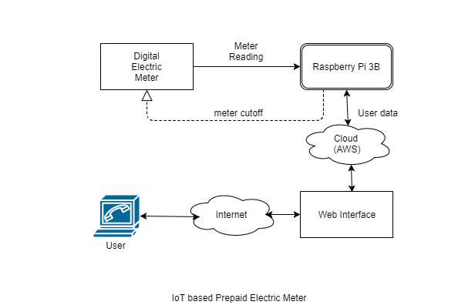

*Fig 1: Block Diagram*

Digital Electric Meter:

An electricity meter, electric meter, electrical meter, or energy meter is a device that measures the amount of electric energy consumed by a residence, a business, or an electrically powered device.

Raspberry Pi 3 Model B:

The Raspberry Pi is a series of small [single-board computers](https://en.wikipedia.org/wiki/Single-board_computer) developed in the [United Kingdom](https://en.wikipedia.org/wiki/United_Kingdom) by the [Raspberry Pi Foundation](https://en.wikipedia.org/wiki/Raspberry_Pi_Foundation) to promote the teaching of basic computer

science in schools and in [developing countries](https://en.wikipedia.org/wiki/Developing_countries). The original model became far more popular than anticipated, selling outside of its [target market](https://en.wikipedia.org/wiki/Target_market) for uses such as [robotics](https://en.wikipedia.org/wiki/Robotics). Peripherals (including [keyboards](https://en.wikipedia.org/wiki/Keyboard_(computing)), [mice](https://en.wikipedia.org/wiki/Mouse_(computing)) and [cases](https://en.wikipedia.org/wiki/Computer_case)) are not included with the Raspberry Pi. Some accessories however have been included in several official and unofficial bundles.

Cloud Database:

Amazon Web Services (AWS) is a subsidiary of [Amazon.com](https://en.wikipedia.org/wiki/Amazon.com) that provides [on-demand](https://en.wikipedia.org/wiki/Software_as_a_service) [cloud computing](https://en.wikipedia.org/wiki/Cloud_computing) [platforms](https://en.wikipedia.org/wiki/Computing_platform) to individuals, companies and governments, on a paid subscription basis with a free-tier option available for 12 months. The technology allows subscribers to have at their disposal a full-fledged [virtual](https://en.wikipedia.org/wiki/Virtualization) [cluster of computers](https://en.wikipedia.org/wiki/Computer_cluster), available all the time, through the internet. AWS's version of virtual computers have most of the attributes of a real computer including hardware (CPU(s) & GPU(s) for processing, local/RAM memory, hard-disk/SSD storage); a choice of operating systems; networking; and pre-loaded application software such as [web servers](https://en.wikipedia.org/wiki/Web_server), [databases](https://en.wikipedia.org/wiki/Database), [CRM](https://en.wikipedia.org/wiki/Customer_relationship_management), etc. Each AWS system also virtualizes its [console](https://en.wikipedia.org/wiki/System_console) I/O (keyboard, display, and mouse), allowing AWS subscribers to connect to their AWS system using a modern [browser](https://en.wikipedia.org/wiki/Web_browser). The browser acts as a window into the virtual computer, letting subscribers [log-in](https://en.wikipedia.org/wiki/Login), [configure](https://en.wikipedia.org/wiki/Configuration_management) and use their virtual systems just as they would a real physical computer. They can choose to deploy their AWS systems to provide internet-based services for their own and their customers' benefit.

**4.2 Modular Design of the system**

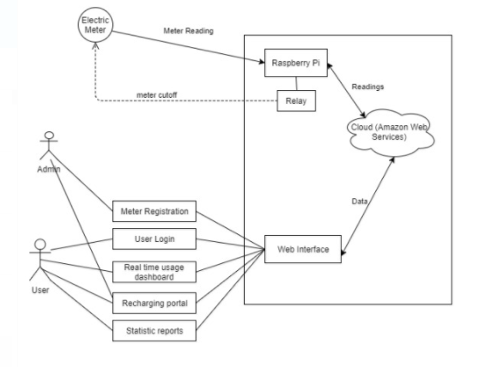

*Fig 2: Modular Diagram*

The above diagram shows the design of the proposed system. The system consists of a Raspberry Pi, Cloud service (Amazon Web Service) and a web interface. From the electric meter, the readings will be sent to Raspberry Pi. Raspberry Pi will then calculate the amount of units consumed and compare it with the user’s available balance which it gets from cloud. If user has sufficient balance, electricity supply is as usual. If balance is low, notifications and alerts are sent to the user urging him to recharge. Finally, if balance is zero, electricity supply is cut with the help of a relay circuit. Using the web interface, user can perform functions like recharging, checking balance at real time, obtain daily, weekly and monthly reports of consumption. Administrator is responsible for registering a meter and its corresponding user.

There are 5 major modules in the web interface:

Meter Registration – The administrator performs the registration of a meter to a user.

User Login – This feature will be used by the user to login to the system and view his account information.

Realtime usage dashboard – This dashboard will show the real time usage in terms of balance remaining of the user which will be updated every 15 minutes.

Recharging portal – This can be used by the user after he is logged in to recharge his account either through credit/debit card or net banking.

Statistic reports- This view is enabled only after the user logs in the system. He can view the daily, weekly or monthly history of his consumption and decide the recharge his account accordingly and further plan his expenses.

**4.3 Detailed Design**

**4.3.1 Data Flow Diagram**

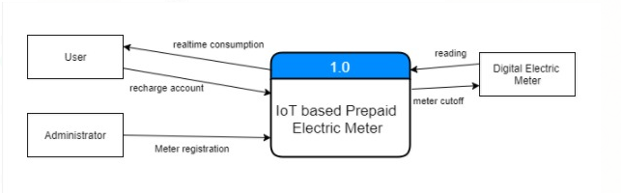

*Fig 3.1: DFD Level 0*

There are 3 actors in the scenario – user, administrator and digital electric meter.

Digital electric meter- Readings are obtained from the meter. In case of insufficient balance, the system will shut off the supply.

User- The user can recharge his account and can view the real time consumption from the system.

Administrator – He looks after meter registration. It registers the meter to a user.

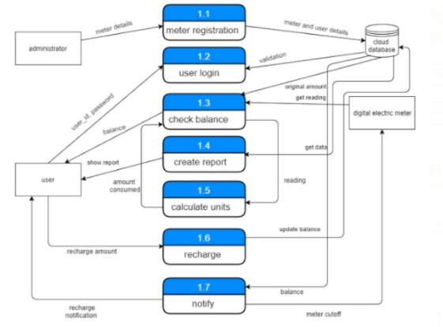

*Fig. 3.2: DFD Level 1*

* 1. Meter Registration – The administrator provides the meter details and corresponding user details and this is stored in the cloud database.
  2. User Login – The user uses his user_id and password to login which is validated by comparing in the database.
  3. Check Balance – It gets the readings from the meter, gets the amount consumed from the calculate units module and returns the balance to the user.
  4. Create Report – This module gets data from the database, prepares the daily, weekly or monthly report as specified by the user and shows the report to the user.
  5. Calculate Units – It gets the meter readings and calculates the amount consumed by using the formula.
  6. Recharge – User specifies the recharge amount and the balance is updated in the database.
  7. Notify – this module is responsible for sending notifications to the user incase of low balance and incase of insufficient balance, it cuts off the meter.

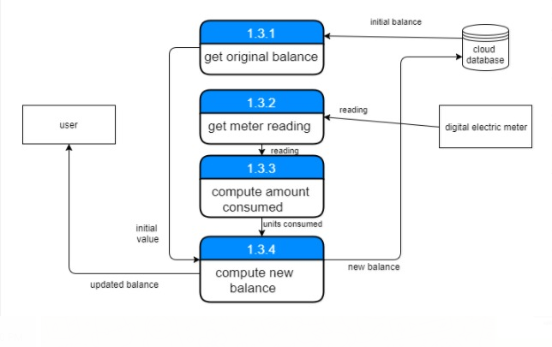

*Fig. 3.3: DFD level 2*

1.3.1 get original balance – It gets the initial balance amount of the user from the database.

1.3.2 get meter reading – It obtains the meter reading from the digital electric meter.

1.3.3 compute amount – It computes the amount consumed.

1.3.4 compute new balance – It takes the initial amount and units consumed and calculates the new balance.

**4.3.2 Flowchart of the proposed system**

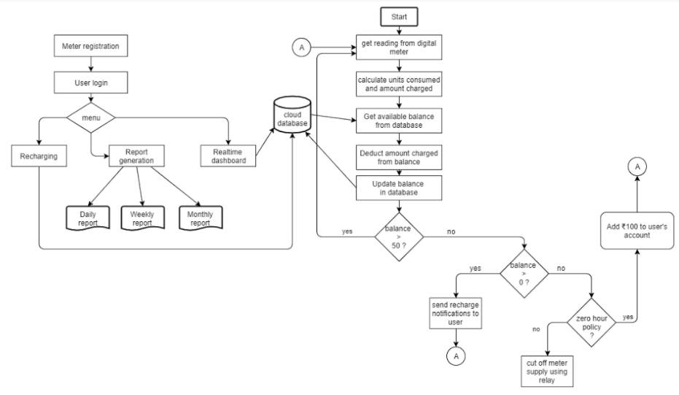

*Fig. 4: Flowchart*

The process starts with getting readings from the electric meter. Calculate the units consumed and get the initial balance from the cloud database. Update the new balance in the database. If the balance is less than 50, we send notifications to the user and if balance is 0 and if zero hour policy is opted, then we add 100 rupees to the account, if not the supply is cut off.

The meter is registered to the user. The user then logins in to the system. He can perform one of the following functions:

1. Meter Registration – The administrator performs the registration of a meter to a user.
2. User Login – This feature will be used by the user to login to the system and view his account information.
3. Realtime usage dashboard – This dashboard will show the real time usage in terms of balance remaining of the user which will be updated every 15 minutes.
4. Recharging portal – This can be used by the user after he is logged in to recharge his account either through credit/debit card or net banking.
5. Statistic reports- This view is enabled only after the user logs in the system. He can view the daily, weekly or monthly history of his consumption and decide the recharge his account accordingly and further plan his expenses.

**4.4 Project Scheduling and tracking using Gantt chart**

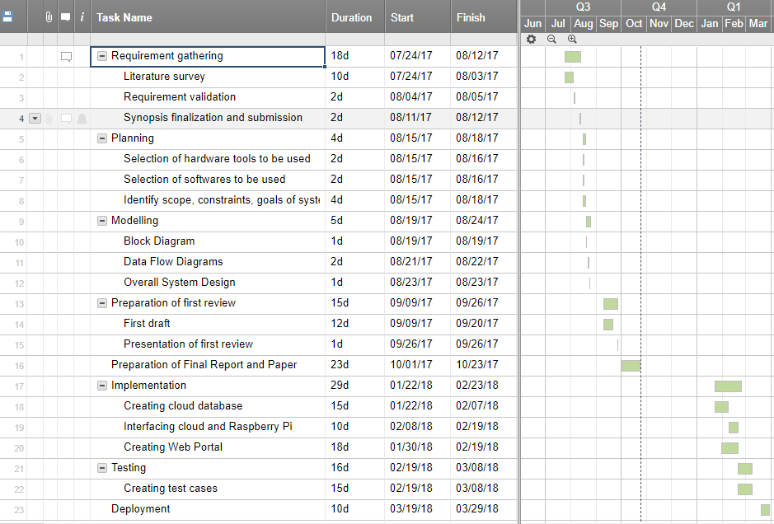

*Fig. 5: Gantt chart*

**CHAPTER 5: IMPLEMENTATION DETAILS**

Implementation encompasses all the processes involved in getting new software or hardware operating properly in its environment, including installation, configuration, running, testing, and making necessary changes. The GUI and result of the system is described briefly. Here, the various models which are been implemented in our project are mentioned.

**5.1 Algorithms for the respective modules developed**

1. Tracking algorithm

This is used to track the changes in reading. As soon as the value of seven segment display changes, a code is triggered which reflects the changes in the cloud database and subsequently on the web interface.

Code:

function relayOff(){

if(count >= data1){

relay.write(0, function(err){

if (err) throw err;

console.log('relay-off');

});

relay.unexport();

}

else return; }

gpio.on('change', function(channel, value) {

console.log('Channel ' + channel + ' value is now ' + value);

count++;

console.log(count,data1);

if(count >= 10){

count = count % 10;

count--;

}

if(count >= 100){

count = count % 100;

count--;

}

var a=10;

var b=7;

var c=19;

var d=23;

var e=18;

var f=27;

var g=06;

var dot=9;

gpio.setup(a, gpio.DIR_OUT, write);

gpio.setup(b, gpio.DIR_OUT, write);

gpio.setup(c, gpio.DIR_OUT, write);

gpio.setup(d, gpio.DIR_OUT, write);

gpio.setup(e, gpio.DIR_OUT, write);

gpio.setup(d, gpio.DIR_OUT, write);

gpio.setup(f, gpio.DIR_OUT, write);

gpio.setup(g, gpio.DIR_OUT, write);

gpio.setup(dot, gpio.DIR_OUT, write);

var numbers = {

"one" : [false,true,true,false,false,false,false],

"two" : [true,true,false,true,true,false,true,],

"three": [true,true,true,true,false,false,true],

"four": [false,true,true,false,false,true,true],

"five": [true,false,true,true,false,true,true],

"six": [true,false,true,true,true,true,true],

"seven" : [true,true,true,false,false,false,false],

"eight" : [true,true,true,true,true,true,true],

"nine" : [true,true,true,false,false,true,true],

"zero" : [true,true,true,true,true,true,false],

};

function write(err) {

if(count == 1){

gpio.write(a, numbers.one[0]) ;

gpio.write(b,numbers.one[1]) ;

gpio.write(c, numbers.one[2]) ;

gpio.write(d,numbers.one[3]) ;

gpio.write(e, numbers.one[4]) ;

gpio.write(f, numbers.one[5]) ;

gpio.write(g, numbers.one[6]) ;

gpio.write(dot,true) ;

putData();

relayOff();

}

if(count == 0){

gpio.write(a, numbers.zero[0]) ;

gpio.write(b,numbers. zero [1]) ;

gpio.write(c, numbers. zero [2]) ;

gpio.write(d,numbers. zero [3]) ;

gpio.write(e, numbers. zero [4]) ;

gpio.write(f, numbers. zero [5]) ;

gpio.write(g, numbers. zero [6]) ;

gpio.write(dot,true) ;

putData();

relayOff();

}

if(count == 2){

gpio.write(a, numbers.two[0]) ;

gpio.write(b,numbers.two[1]) ;

gpio.write(c, numbers.two[2]) ;

gpio.write(d,numbers.two[3]) ;

gpio.write(e, numbers.two[4]) ;

gpio.write(f, numbers.two[5]) ;

gpio.write(g, numbers.two[6]) ;

gpio.write(dot,true) ;

putData();

relayOff();

}

.

.

.

.

if(count == 9){

gpio.write(a, numbers.nine[0]) ;

gpio.write(b,numbers.nine[1]) ;

gpio.write(c, numbers.nine[2]) ;

gpio.write(d,numbers.nine[3]) ;

gpio.write(e, numbers.nine[4]) ;

gpio.write(f, numbers.nine[5]) ;

gpio.write(g, numbers.nine[6]) ;

gpio.write(dot,true) ;

putData();

relayOff();

});

function putData() {

var params = {

Item:{

id : "0" ,

message : count.toString(),

},

TableName : 'consumption'

};

docClient.put(params, function(err,data){

if (err) {

console.log('Error saving Data!',err.stack);

} else {

console.log('Data Saved!', data);

}

}); }

**5.2 Comparative analysis with the existing Algorithms**

|  |  |
| --- | --- |
| **Existing System** | **Prepaid Electric Meter** |
| Payment is done after electricity is consumed. | Payment is done before consuming electricity. |
| There is no feature of keeping a track of the units consumed. | We can generate a set of graphs as the data regarding consumption is saved in the database. |
| We cannot view the real-time consumption of units. | We can view the units consumed in real time using cloud. |
| Problem of electricity theft goes undetected. | Problem of electricity theft can easily be detected. |
| Lower accuracy as human intervention is needed to take the reading at the end of each month. | Higher accuracy as human intervention is completely removed from the process. |

*Table 1: Comparison between existing and proposed system*

**5.3 Evaluation of the developed System**

|  |  |
| --- | --- |
| Parameter | Time Taken (in seconds) |
| Time taken to update cloud (on consumption) | 0.3-1.5 |
| Time taken to update value in web interface (on consumption) | 0.5-1.8 |
| Time taken to update cloud (on recharge) | 1.5-2.6 |
| Time taken to update Raspberry Pi (on recharge) | 1.4-2.6 |

*Table 2: Evaluation of the system*

**CHAPTER 6: TESTING**

In this chapter, various modules of the system are tested, discussing how easily the system can be used by the user of the system. Various types of testing such as unit testing, integration testing and user acceptance testing are performed in this chapter.

**6.1 Unit Testing**

In this stage of testing, the individual units of the application are tested. The errors reported during the test are fixed and the testing is performed recursively until all the errors are fixed and the application gives desired output as mentioned in the requirements.

The following table shows the various test cases under unit testing:

|  |  |  |  |  |  |
| --- | --- | --- | --- | --- | --- |
| Test Case No. | Test Case Description | Input | Output | Actual Output | Pass/Fail |
| 1 | Creating connection to Raspberry Pi. | Raspberry Pi is connected to the Wi-Fi. | A connection is made to Raspberry Pi. | IP Address is obtained using Advanced IP Scanner and connection is made using Remote Desktop Connection. | Pass |
| 2 | Storing real time value in DynamoDB | Input from the 7-segment display. | The value from 7 segment display is stored in database. | The value from 7 segment display is displayed on AWS Console and stored in DynamoDB within 3 seconds. | Pass |
| 3 | Checking threshold condition | Value on 7 segment display. | The bulb should turn off. | The bulb goes off after crossing the threshold value immediately. | Pass |
| 4 | Recharge portal | User enters recharge amount of web interface. | The recharge details must be reflected in cloud and web interface. | The recharge details must be reflected in cloud and web interface within 2 seconds. | Pass |

*Table 3: Unit testing cases*

**6.2 Integration Testing**

The reading from the 7 segment display is sent to the cloud and from there it is displayed in the web interface. As soon as the threshold value is reached, the relay cuts off current to the bulb and the bulb goes off. Once recharge is done again, the bulb turns on again. After resolving a few minor bugs, the modules worked perfectly and results are obtained within seconds.

**6.3 User Acceptance Testing**

The system is tested on multiple users of technical competence to understand the user acceptance of the application. Within a few minutes, the users were able to use to application easily. With a simple UI design, the users were easily able to understand how to navigate around the web interface. The users were able to explore the features of the app by themselves.

Some of the comments given by the users were:

* The UI is consistent, familiar and responsive.
* Layout is simple so its easy to use.
* The graphs are useful to track my usage.
* The results are obtained within few seconds.

**CHAPTER 7: RESULT ANALYSIS**

The Result Analysis focuses mainly on the working aspect i.e. what all functions are provided in the system, the screenshots attached in this chapter helps in better understanding to the user as how the system will look like (User Interface).

**7.1 Simulation Model**

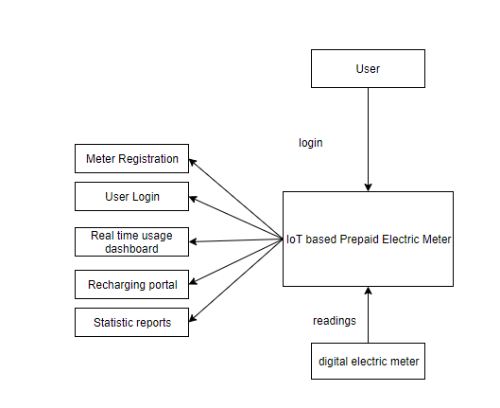

*Fig 6: Simulation Model*

The readings from the electric meter are recorded by the system. The user can login to the system and performs tasks like view real time usage, recharge and generate statistical reports for his account. After threshold is reached the relay automatically cuts off electricity supply.

**7.2 Screenshots of the User Interface**

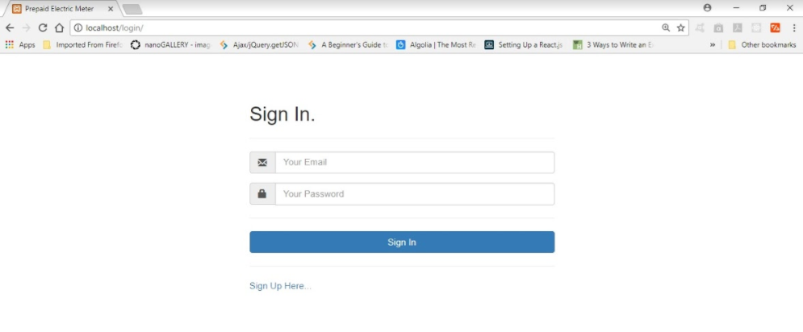

*Fig 7: Sign In*

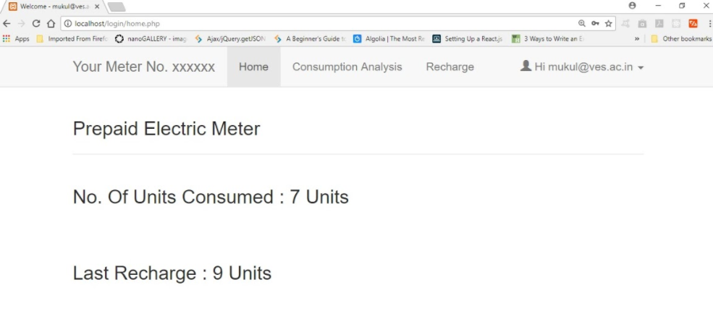

*Fig 8: Real time usage page*

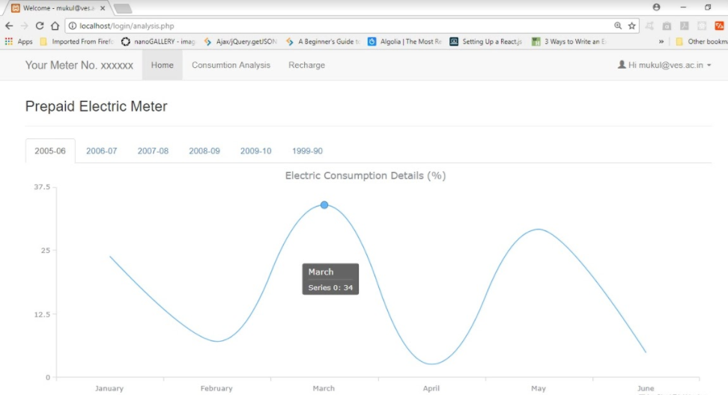

*Fig 9: Statistical graph*

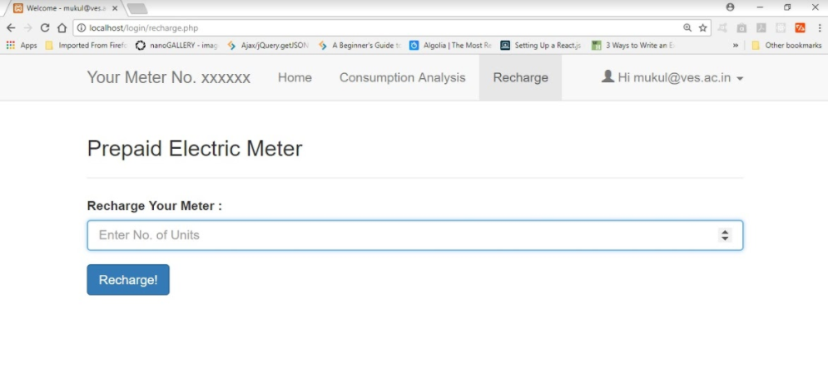

*Fig 10: Recharge portal*

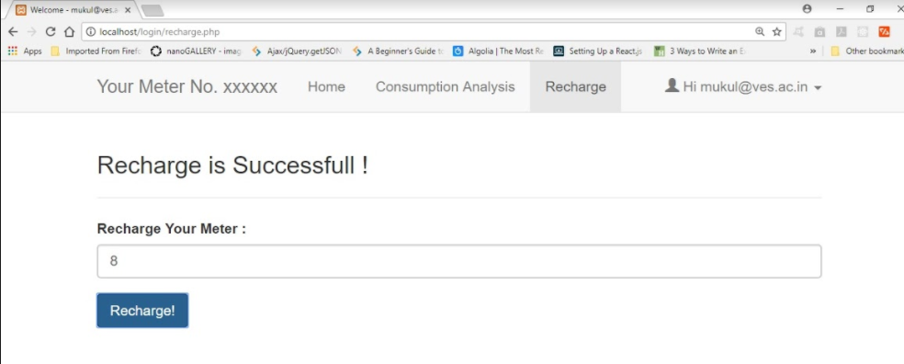

*Fig 11: Recharge successful*

**7.3 Reports Generated**



*Fig 12: Consumption reports generated yearly and monthly*

**CHAPTER 8: CONCLUSION**

This chapter discusses the Limitations and Future Scope of our project. The summarization of the project is also done over here.

**8.1 Limitations**

Using electric meter for educational purposes is not allowed, so we have used 7 segment display to represent meter reading and a bulb represent the meter. For actual implementation, we need to connect Raspberry Pi to the electric meter which is not considered in our project. Raspberry Pi is a costly device and hence installation cost will be high as each meter will need one Raspberry Pi.

**8.2 Conclusion**

Thus, this project addresses an old but unsolved problem of making the electricity billing system prepaid. As it shows the real time consumption of electricity, we hope that the users will be conscious about their consumption and will try to save electricity even if its just 0.01%. The web interface bridges the gap between the user and the cloud system.

**8.3 Future Scope**

By using Machine Learning algorithms, our system can be trained by the current data set and can predict the amount of recharge a user must do for the next month. Also, trends can be searched by using Big Data Analytics to find out in which months consumption is more.

**REFERENCES**

[1] Prepaid Energy Meter for Billing System Using Microcontroller and Recharge Card, International Journal Of Core Engineering & Management (IJCEM), Volume 1, Issue 1, April 2014. ISSN:2348 9510.

[2] A Smart Prepaid Energy Metering System to Control Electricity Theft, 2013 International Conference on Power, Energy and Control (ICPEC).

[3] Raspberry Pi based automatic meter reading, International Journal of Application or Innovation in Engineering & Management (IJAIEM), Volume 5, Issue 9, September 2016. ISSN 2319 – 4847.

[4] Automated Energy Meter Using WiFi Enabled Raspberry Pi, IEEE International Conference On Recent Trends In Electronics Information Communication Technology, May 20-21, 2016, India.

[5] S. Shahidi, M. A. Gaffar and K. M. Salim, "Design and implementation of digital energy meter with data sending capability using GSM network," Advances in Electrical Engineering (ICAEE), 2013 International Conference on, Dhaka, 2013, pp. 203-206.

[6] A. C. D. Bonganay, J. C. Magno, A. G. Marcellana, J. M. E. Morante and N. G. Perez, "Automated electric meter reading and monitoring system using ZigBee-integrated raspberry Pi single board computer via Modbus," Electrical, Electronics and Computer Science (SCEECS), 2014 IEEE Students' Conference on, Bhopal, 2014, pp. 1-6.J.

**PROJECT REVIEWS**

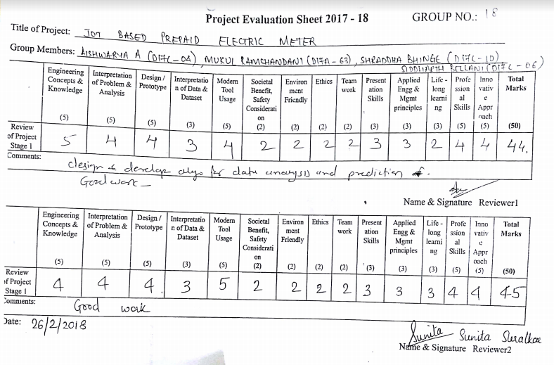

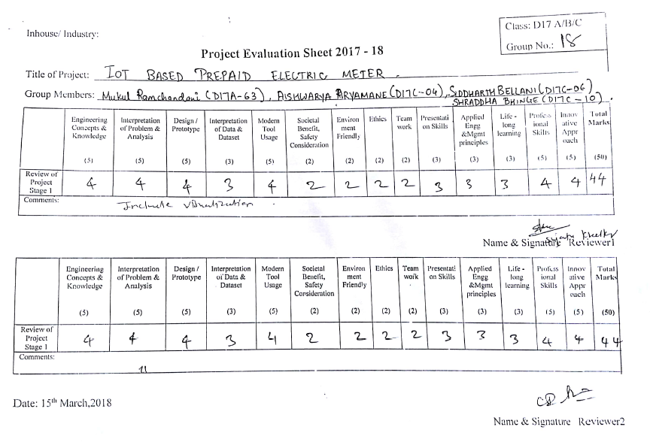

**APPENDIX**

**PAPER 1: Presented in ICIATE’18 (International Conference on Innovative and Advanced Technologies in Engineering)**

Proposed Prepaid Electric Meter

Mrs. Indu Dokare , Assistant Professor, Computer Engineering , VESIT – Chembur, Mumbai-74

Siddharth Bellani , BE Computer Engineering , VESIT – Chembur, Mumbai-74

Mukul Ramchandani , BE Computer Engineering , VESIT – Chembur, Mumbai-74

Aishwarya Aryamane , BE Computer Engineering , VESIT – Chembur, Mumbai-74

Shraddha Bhinge , BE Computer Engineering , VESIT – Chembur, Mumbai-74

**Abstract**— The curve for the demand for electricity in India has always been on the increasing side while the curve for the supply has been on the decreasing side. This paper proposes an IoT based prepaid electric billing meter with an objective to let the end user know his/her real time consumption of electricity. This will enable users to make a conscious effort to reduce consumption. The end user can track his/her real time consumption of electricity on the web interface with a unique login id and password. The end user can also recharge from the same interface. This real time awareness of consumption will also help end user to control his/her electricity theft.

***Keywords* – prepaid electric meter, IoT based electric meter, Raspberry Pi.**

1. Introduction

The electricity billing system has been post-paid over the years in India. In case of mobile system, it is both that is prepaid and post-paid, the analytics shows that prepaid users have lesser phone bills as compared to post-paid. With this analogy of telecom system, the electricity billing system can also be made prepaid and can prove helpful to reduce consumption of electricity in India.

The non-linearity in the graph of availability versus requirement for electricity has been eventually increased in the past few years in India. Due to the post-paid billing system people are not aware of the way or amount of electricity (real-time) they are using on daily/monthly basis. The real time statistics can be very helpful for the consumption of electricity.

The consumption of electricity and the above scenario can be controlled by introducing the prepaid billing facility in the electric meter.

The IoT based prepaid electric billing meter will be connected to the web-interface through a cloud based infrastructure. In addition, the same interface will be used for recharging and tracking the real time electricity purposes. The whole system is designed in such a manner that null balance will lead to electricity cut-off.

1. Existing Systems

The post-paid electricity billing system already involves a lot of labour work and efforts. The major disadvantage with this system is the possibility of human error, the person taking readings may make a mistake. In addition, the current system is a post-paid one, we know the bill only at the end of the month. There is huge scope for electricity theft [2]. Accuracy is also an issue. In spite of this post-paid billing system, few prepaid systems have been proposed and developed. One of the method that has been proposed [2] was based on using Microcontroller and which uses the Recharge Card of various ranges like **₹**50, 100, etc. and meter can be recharged using keypad present on it. The measures taken to reduce the control the electricity theft by developing the prepaid system[1] using GSM/GPRS infrastructure in which the recharge can be done through SMS and here as well microcontroller is used. Getting the readings from the electric meter is one of the challenging tasks in developing such prepaid systems and hence one of the way that existing system[3] is proposed uses a camera to capture the image, captured image is pre -processed to get display plate and characters are recognized by processor Raspberry Pi using contour algorithm, by taking difference between two readings of consecutive months billing is done and send it to the consumer using GSM / GPRS[4] wireless technology. Another system[8] integrates the ZigBee protocol in Raspberry Pi using Python and using Python the raw data is converted into a .CSV file which acts as input to the MySQL database and the data is uploaded on the website.

The technologies like GPRS has almost become outdated and the internet is getting cheaper day by day

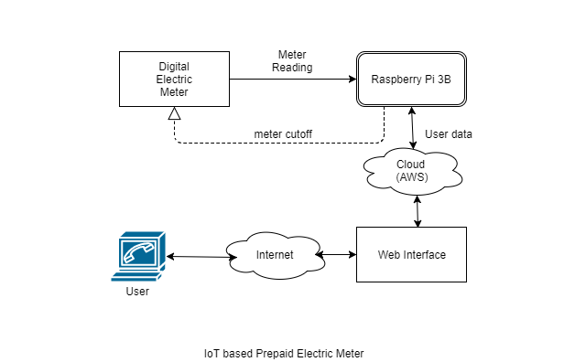especially in the developing country like India. Hence, the prepaid system with cloud infrastructure is necessary to be developed, as the sending real time track of consumption is quite an easier task using cloud at least easier than developing the GSM/GPRS infrastructure.

Fig. 1: Block diagram

1. Proposed System

The IoT based prepaid electric meter will be developed using the Raspberry Pi model 3B [6] and other few electric components will be used to maintain the contact with the electric meter. The front end of the system will be web-interface based and connected to the cloud infrastructure and the same cloud infrastructure will be connected to the Raspberry Pi. Fig.1 shows the block diagram and Fig 2 shows the complete overview of the project.



Fig 2: System Diagram

1. Methodology applied to the proposed system

One of the important challenging in developing the prepaid systems is getting the readings of the digital meter and further these values are used for controlling the meter. The complete methodology for the constructing the same is as follows:

1. *Getting the Meter Reading:* The Raspberry Pi has like more than 20 GPIO (general-purpose input output) pins [9] structure which can be used to connect different modules to the Pi. The digital meter contains the seven-segment LED display. The same LED system will be connected to the raspberry pi and readings taken can be used for the further manipulation of the electric meter.
2. *Controlling the electric meter:* Relays are one of the best electric components when it comes to switching the electric circuits. The proposed system bridges the end user and the electric meter with raspberry pi with the cloud infrastructure [7]. The cloud infrastructure contains the whole user info like his/her remaining balance details, recharging details etc. and these same details are used to switch the
3. electric meter on/off. The null balance can lead to the electricity cut-off and will be automatically switched on as soon as the recharge is done.
4. *Web-Interface:* The UI/UX part maintains the connection between the hardware and software. The front-end [4] of the system will be totally web-interface based. The web-interface will contain the end users’ login/registration details and users’ balance details. The interface will show/track the real time consumption of the registered users and will show the usage/consumption details till particular date in a graphical manner. The recharge of the electric meter can be done through same interface. As discussed, the interface is connected to the cloud and further the cloud infrastructure is connected to Pi. The figure below shows the architectural design of the proposed system:

1. proposed results

The proposed method provides the communication between the Electricity Board section and the consumer section using Internet of things (IOT) for transmitting the customer’s electricity consumption and bill information that is calculated using Raspberry Pi. Since IOT is cost effective compared to SMS, monitoring of energy meters at lower cost is made possible. Daily consumption reports and monthly graphs are generated which can be monitored through web interface. The users will also receive push notification on their web portal about their daily, monthly consumption of electricity, reminder about units left. The human intensive work is avoided and all the values are maintained with the help of cloud computing. Since the values are stored in the cloud, the reports will be accessible from anywhere in the world. In addition, the server will be online 24x7. This meter will have an emergency credit facility that allows you to ‘borrow’ money from the meter if your credit runs low.

1. Conclusion

This paper proposes an IoT based prepaid electric meter, which tracks the real-time consumption of electricity and display the same over the web-interface.The main advantages of the Proposed System is that the users can be aware of their electricity consumption and control their consumption. Theft of electricity can be avoided by tamper proof energy meters. The errors in the system can be identified quickly. The proposed system can also be helpful for decreasing the electricity consumption as the users of the system will have the prepaid mindset. Further, the human work of collecting readings by visiting every home at the end of every month can be avoided by generating Electricity bills automatically.

1. References
2. Prepaid Energy Meter for Billing System Using Microcontroller and Recharge Card , International Journal Of Core Engineering & Management(IJCEM) ,Volume 1, Issue 1, April 2014. ISSN:2348 9510.
3. A Smart Prepaid Energy Metering System to Control Electricity Theft, 2013 International Conference on Power, Energy and Control (ICPEC).
4. Raspberry Pi based automatic meter reading, International Journal of Application or Innovation in Engineering & Management (IJAIEM), Volume 5, Issue 9, September 2016. ISSN 2319 – 4847.
5. Automated Energy Meter Using WiFi Enabled Raspberry Pi , IEEE International Conference On Recent Trends In Electronics Information Communication Technology, May 20-21, 2016, India.
6. S. Shahidi, M. A. Gaffar and K. M. Salim, "Design and implementation of digital energy meter with data sending capability using GSM network," Advances in Electrical Engineering (ICAEE), 2013 International Conference on, Dhaka, 2013, pp. 203-206.
7. Raspberrypi.org – Official website and its documentation.
8. https://aws.amazon.com/documentation/ - Amazon Web Services Official Documentation
9. A. C. D. Bonganay, J. C. Magno, A. G. Marcellana, J. M. E. Morante and N. G. Perez, "Automated electric meter reading and monitoring system using ZigBee-integrated raspberry Pi single board computer via Modbus," Electrical, Electronics and Computer Science (SCEECS), 2014 IEEE Students' Conference on, Bhopal, 2014, pp. 1-6.J.
10. Pihut.com – Website for raspberry pi projects.

**Plagiarism report**

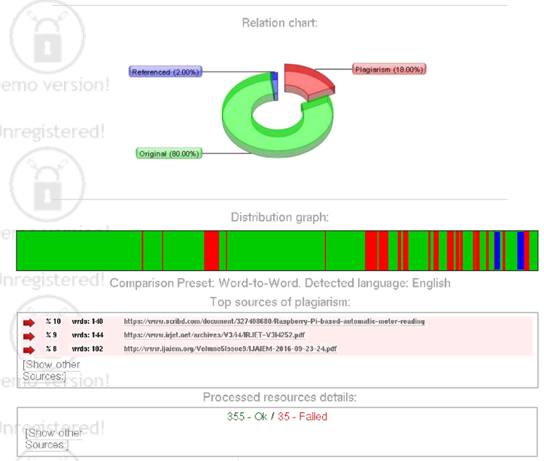

**Certificate of presentation**



